**Created with an evaluation copy of Aspose.Words. To remove all limitations, you can use Free Temporary License** [**https://products.aspose.com/words/temporary-license/**](https://products.aspose.com/words/temporary-license/)

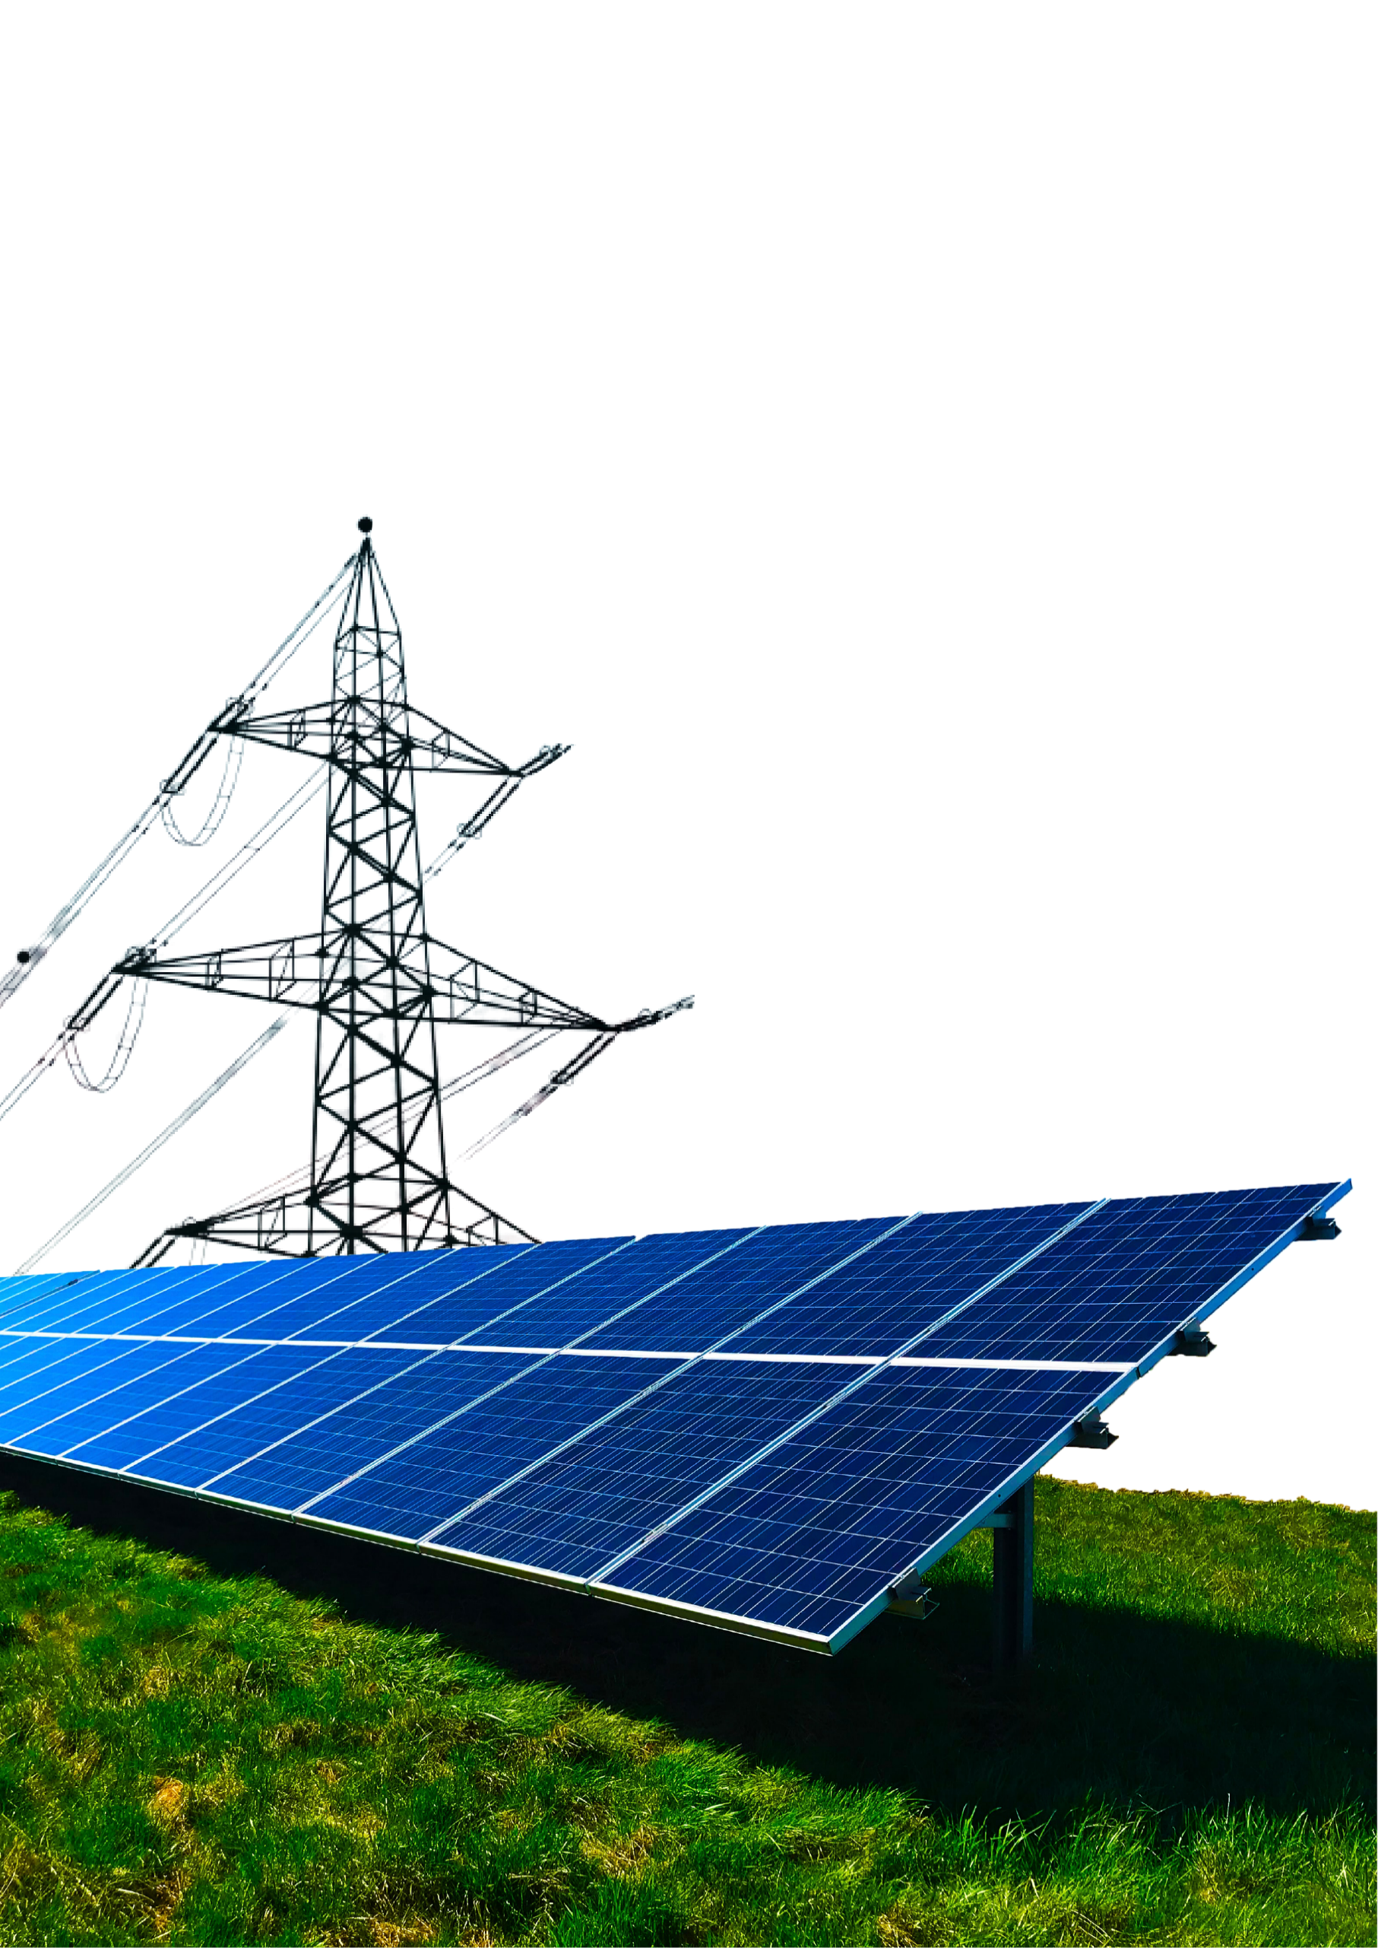

**Technical Proposal**

Sir,

Thank you for giving SolarFlare the opportunity to promote clean energy and a safer environment for our future generation. It’s a noble thing to care for nature and offset the adverse effects on our environment by our carbon emissions.

The cost of electricity from NEPRA is rising every day, and the importance of maintaining a healthy environment grows every day. Installing a solar energy system is a cost-effective, green, and clean way to reduce your environmental footprint. This comes with an added advantage of decreasing or even eliminating your monthly energy expenditure.

SolarFlare promotes solar energy as it is in-expensive, simple, clean, eco-friendly and the smartest choice of energy. Your rooftop will be harnessing the energy of the abundant nature’s gift to man – Sun. Solar energy is non-polluting and renewable. The average life of a solar system installed by SolarFlare will be 25 years, your new system will offset your carbon footprint by more than 25 tonnes of carbon dioxide which is equal to planting 45 Acres of trees. We want to save electricity bills and manage your energy resources so you always have the highest availability of energy at the lowest possible cost.

Our Integrated Monitoring System for the inverters will be available to you 24/7 for monitoring and reporting of the solar system installed at your premises. In the event of any technical problem, SolarFlare can monitor your systems remotely and diagnose the problem and send a member of our technical team to help you fix any issue you can face with your solar energy system.

We hope to help you get more energy independence by providing a good investment for the coming years and helping you make a more positive impact on the environment.

Thanks & Regards,

SolarFlare Team

|  |  |
| --- | --- |
| **System Details** | |
| System Watts | Approximately {SystemKiloWatts} Kilo Watts |
| Panels | Tier-1 Panels Longi/Jinko/JA/Trina– 25 Years Workmanship Warranty |
| Inverter | {InverterName} |
| Structure | {StructureName} |
| Roof Angle | {SystemAngle} |
| System Type | {SystemType} |
| Meter Phase: | 3-Phase Meter Required | Sanctioned Load > {SystemKiloWatts/1.5} Required |

# Technical Details

|  |  |
| --- | --- |
| **Month** | **Units Generation** |
| |  | | --- | | January | | February | | March | | April | | May | | June | | July | | August | | September | | October | | November | | December | | |  | | --- | | {JanuaryUnits} | | {FebruaryUnits} | | {MarchUnits} | | {AprilUnits} | | {MayUnits} | | {JuneUnits} | | {JulyUnits} | | {AugustUnits} | | {SeptemberUnits} | | {OctoberUnits} | | {NovemberUnits} | | {DecemberUnits} | |  | |

**Electricity Units Generation per Month – Estimated with Optimal Conditions**

The proposed system will produce the following energy according to SolarFlare estimates based on optimal conditions.

|  |  |
| --- | --- |
| **Energy Details** | |
| Annual Production | {SumOfMonthlyUnits} Units |
| Average Monthly | {SumOfMonthlyUnits /12} Units |
| Yearly Savings | Rs. {SumOfMonthlyUnits*50} |
| NOTE: This calculation uses optimal conditions for the solar generations and the price of electricity is calculated to be 50 Rs/kWh. | |

# Equipment Details

|  |  |
| --- | --- |
| **Item** | **Description** |
| Solar Panels | {SolarPanelsQuantiy} x {SolarPanelName} |
| Inverter | {InverterQuantity} x {InverterName} |
| Equipment | All Imported/Genuine Equipment  {DcBreakersQuantity} x DC Breakers [CLBE/CNC/Tomzn/Suntree/Schneider/ABB]  {DcSpdQuantity} x DC SPDs [CLBE/CNC/Tomzn/Suntree/Schneider/ABB]  {AcSpdQuantity} x AC SPD [Tomzn/Suntree/Schneider/ABB]  {AcBreakerQuantity} x AC Breaker [Tomzn/Suntree/Schneider/ABB]  External Disconnector Switch – 4Pole [CLBE/CNC/Suntree]  MC4 Connectors Imported  Internal DB Box of High Quality  External DB Box with Canopy  Lightning Arrestor  DC Cable For Installation – [LAPP Germany, Fast, Pakistan Cables]  AC Cable For Installation – Minimum 6mm/16mm/25mm [Fast Cables]  UPVC Pipes, Lugs, Channels, Conduits, Ducts – Only Top Quality All All Pure Copper Equipment for Ground Bores |
| Structure | {StructureQuantity} x {StructureName} |
| Batteries | {BatteryQuantiy} x {BatteryName} |
| Misc. | System Design and Simulations  Structure Installation Electrical Installation  3rd Party Quality Inspection  Transportation of Equipment  AC and DC NEPRA Approvable Bores  Labour Charges |

# SolarFlare VS. Other Installers

|  |  |  |
| --- | --- | --- |
| **Item** | **SolarFlare Other Installers** | |
| Solar Panels | Mono PERC Technology—Tier 1 Panels – Jinko/Longi/JA/Trina-25 Years  International Warranty 580 Watts | Poly/Mono – Tier 1 – 400+ Watts |
| Inverter | Only Tier 1 Inverters —5 Years Warranty | All Inverters |
| Equipment | Imported and Genuine Equipment. No Lot Purchased Or Copy  3ft Pure Copper Lightning Arrestor | Lot Purchased and Counterfeit Products. Some use original.  1ft Lightning Arrestor of lesser purity. |
| Structure | Aluminum Alloy Structure  GI Structure 14 Gauge With Civil Work | GI Structure no Gauge Warranty.  No Civil Work.  Reluctance to install Aluminum Structure. |

**This document was truncated here because it was created in the Evaluation Mode.**